Raspberry Pi Data Acquisition Application

### Overview

The Raspberry PI application for data collection and upload is being developed for the new sensing system. This will be used for sensor related experiments and data collection along with PCB. Firmware for PCB is being developed separately. Data collected will be used by data scientist to develop sensor specific algorithm. The current system of data collection and experiments - Android application communicating with the evaluation board holding the sensors over Bluetooth will be phased out.

### High Level Architecture

AWS

Python - boto

Raspberry Pi 3

* Arm Based Linux Computer
* Runs an application to collect data from PCB and upload it to AWS

PCB

SPI

Sensing System

Display

Regular Monitor / touch screen monitor / LCD display

Raspberry Pi is a Linux based computer. Application running on this platform will have following components: -

* GUI
  + To set the experiment parameters
  + Data visualization
  + Settings
* Communicate with the PCB over SPI. NEA gas sensors will be mounted on the PCB. PCB gets the sensor data. PCB also has temperature and humidity sensors. Raspberry pi will collect all this data from the PCB.
* Put all the collected data in a csv file.
* Send data in csv file to the AWS.

### Technology Stack

Programming Language – Python3

IDE – QT Creator

Python Libraries:–

PyQt5 – For GUI

matplotlib – for plotting graphs

spidev – SPI communication with PCB

boto - A Python interface to Amazon Web Services

MFC interface – TBD

### User Interface

Following screens are complete.

1. Experiment Screen

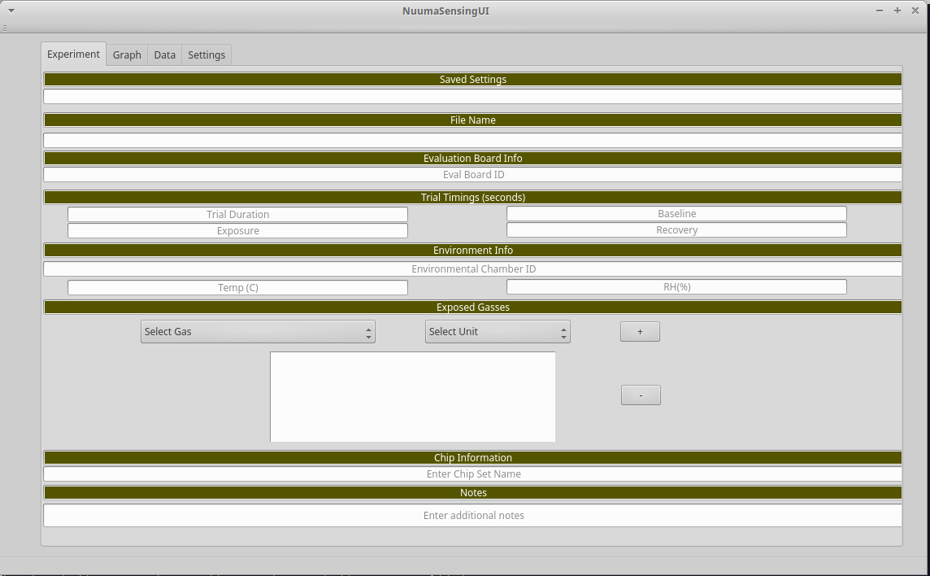

Experiment screen takes various inputs related to the experiment and adds it to the name of csv file and to certain columns in the file. Information entered here will help the data scientist developing the algorithm to understand the data better.

1. Settings Screens

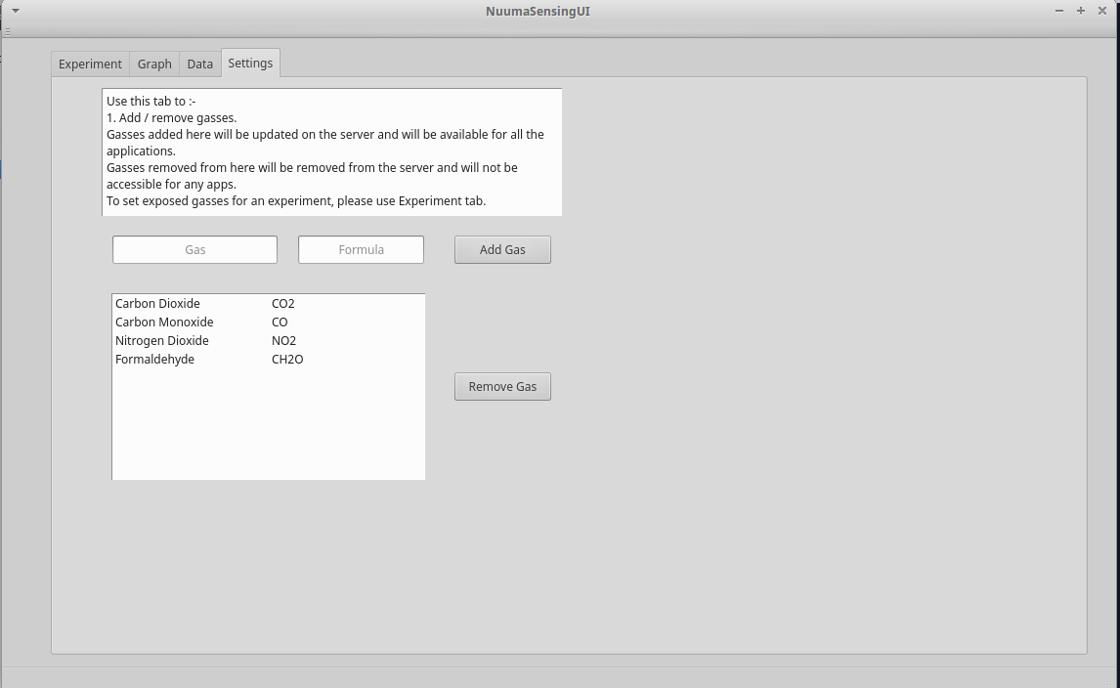

This screen will let the user add and remove the gasses. Gasses added or removed from here will be updated in the “Experiment” screen gas selection combo box. Same will be uploaded on the AWS. Hence will be available to all the applications.

Any other settings related parameters can be added here.

Next Steps –

1. Plot graphs
2. SPI communication with PCB
3. Data compile and upload.
4. MFC interface
5. Ability to run more than one experiments without need to stop.

Possible future features –

1. Database setup on AWS
2. Data processing on AWS.